CSA1411-COMPILER DESIGN

LAB EXPERIMENTS

NAME:- R KALAI AMUDHAN

REG NO:- 192511292

EXPERIMENT – 10:
AIM:-
Implement a C program to eliminate left factoring from a given CFG. S → iEtS / iEtSeS /aE →b
CODE:-
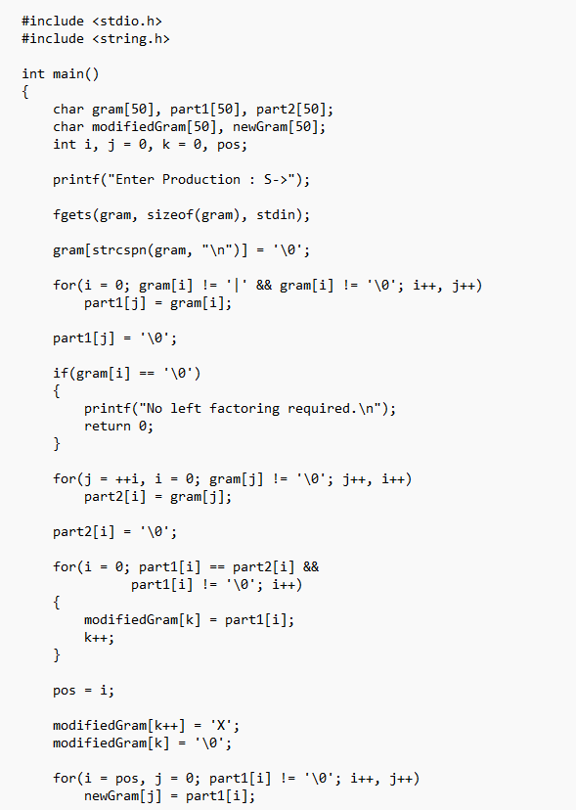
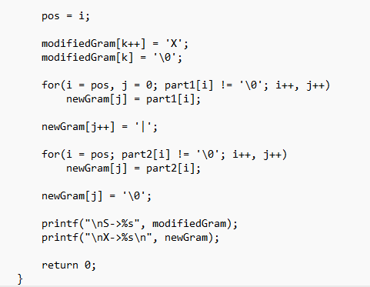

OUTPUT:-
